­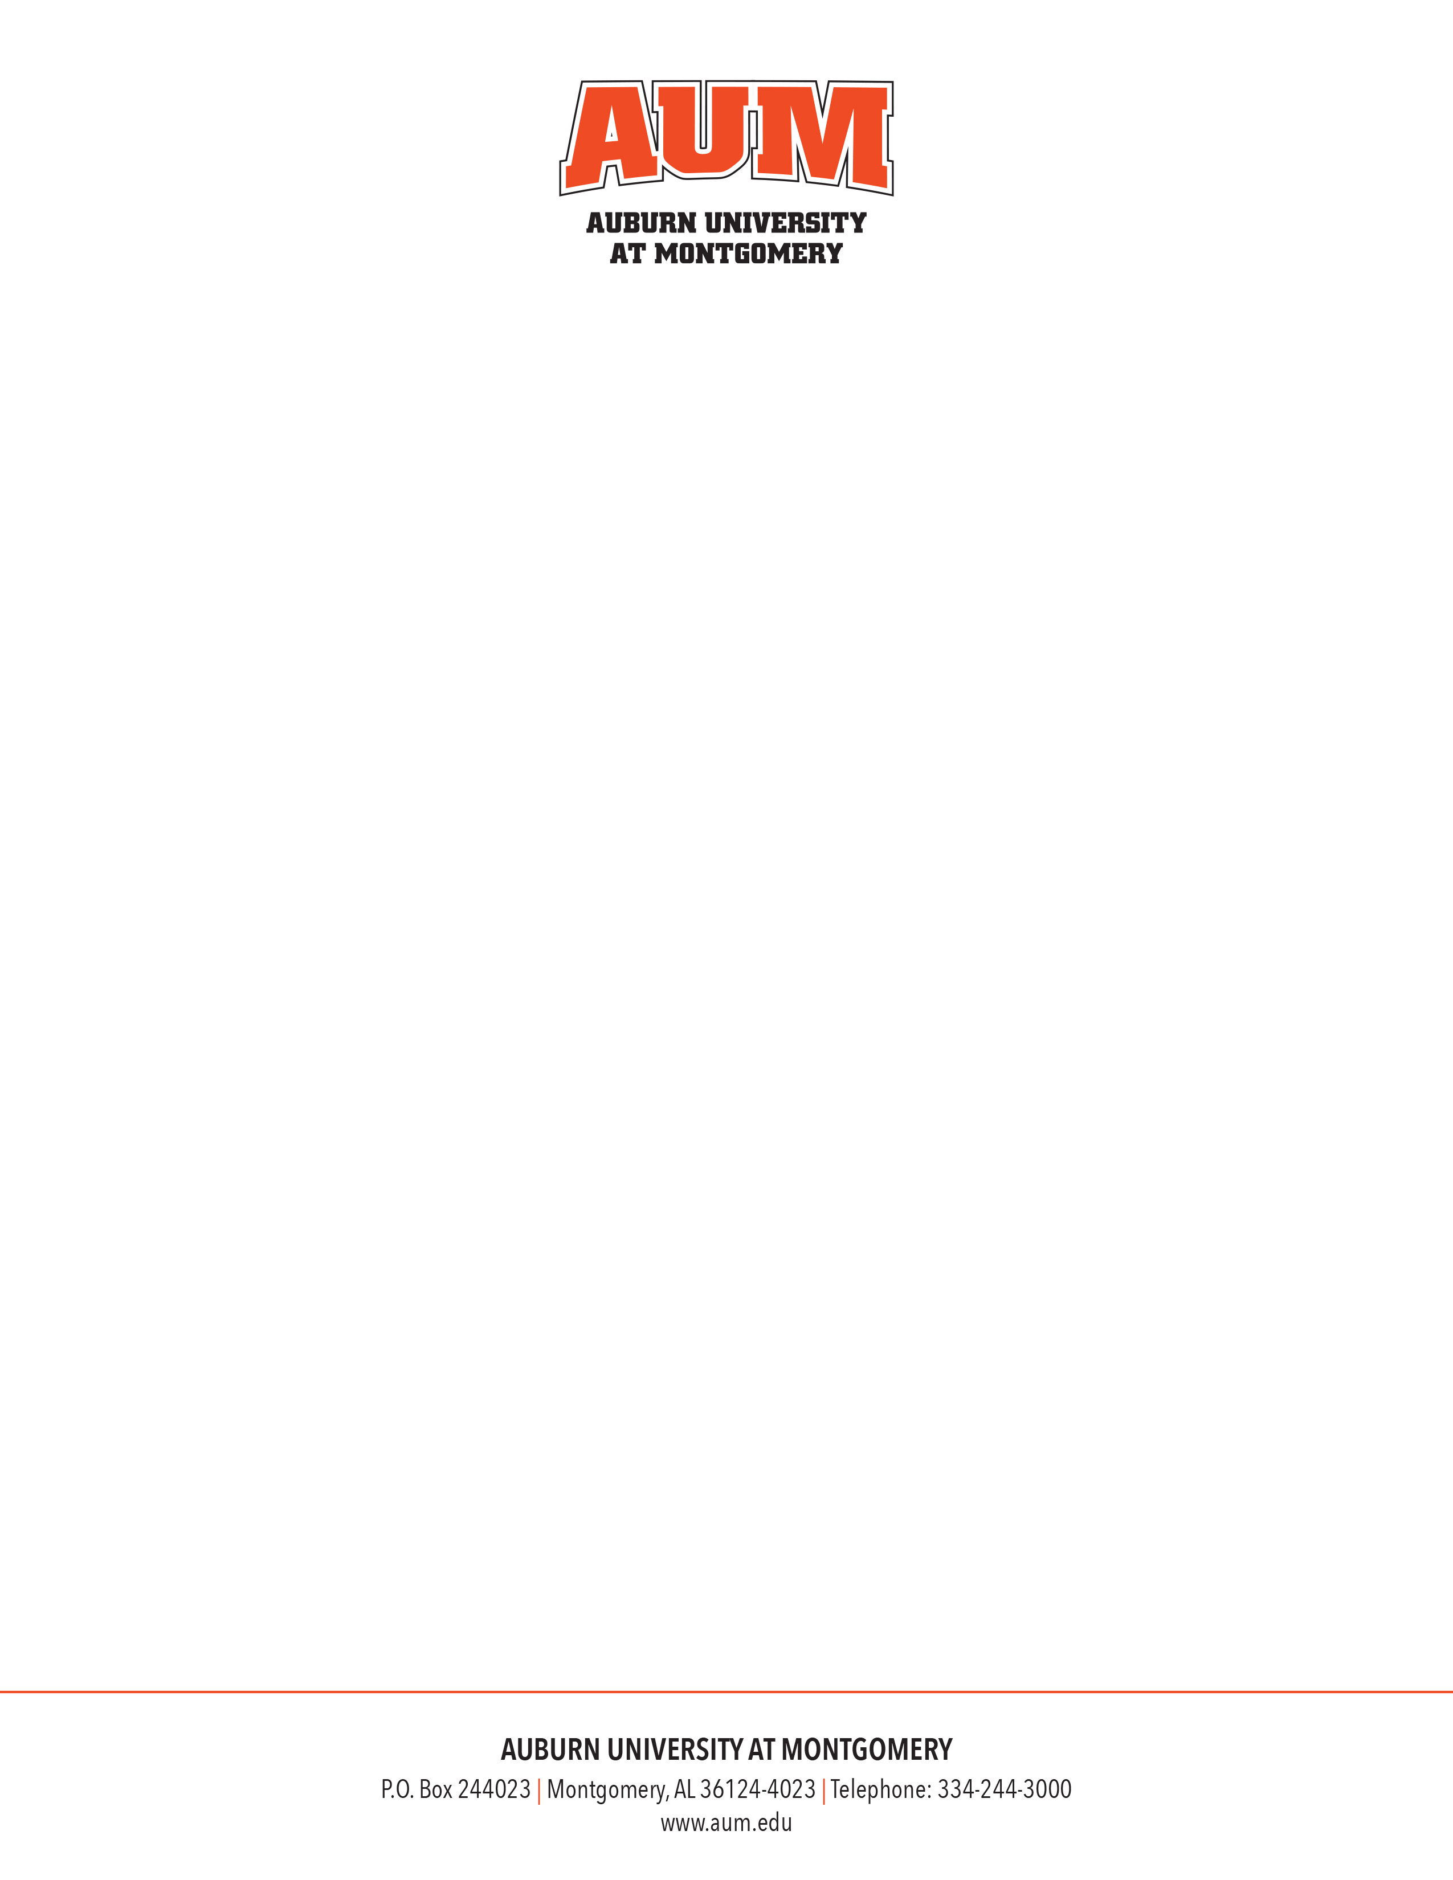

**MEMORANDUM**

**To: Financial Services**

**From: Dean/Department Head**

**Title**

**Department**

**Date:**

**Re: Honorarium – Guest Name (#Banner ID)**

**Name of Event/Reason for Visit – Date of Event/Visit**

The **DEPARTMENT** is honored to have **GUEST** **NAME**, **GUEST TITLE OR POSITION**. **Provide brief bio and/or reasons for why guest is distinguished.**

As a token of our appreciation, we would like to pay an honorarium of $**amount**. This distinguished guest will receive no other payment or travel reimbursement from Auburn University at Montgomery.

**GUEST NAME**

**GUEST ADDRESS**

**FOAP**