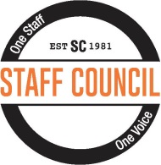
2016 Auburn University Montgomery Staff Council
Staff Council Scholarship Information Sheet

In keeping with the Staff Council’s commitment to provide opportunities for the
personal and professional development of AUM staff, the AUM Staff Council has established five $100.00 scholarships for full-time AUM staff employees
who are enrolled as students at Auburn University at Montgomery.
You must apply by April 11, 2016!

- Applicant must be an AUM employee who has been employed on a full-time basis at Auburn Montgomery for a minimum of one year prior to application.
- Applicant must be enrolled in a degree program at AUM and is required to have successfully completed 12 semester hours of coursework as an undergraduate student or 6 hours as a graduate student and have maintained a grade point average of 2.5 or higher on a 4.0 scale.
- Scholarship awards are not automatically renewed. Applications must be submitted annually.
- Send your completed AUM Staff Council Scholarship Application and your unofficial academic transcript from Webster to: Fariba Deravi, Staff Council President, 114 Administration Building (334) 244-3249, fderav1@aum.edu

The completed application is due Monday, April 11, 2016.

